**Annual Technology Baseline***Links*

* Full interactive report - <https://atb.nrel.gov/electricity/2019/>
* YouTube webinar - <https://www.youtube.com/watch?v=AfCOaPve36o>

**You Tube Webinar** (<https://www.youtube.com/watch?v=AfCOaPve36o>)

* 7:15 – What is different between base year and dollar year?
* 9:20 – What is the black line, “representative value”? Why is it at the low end of the range for onshore wind? Why are there two representative values for offshore wind?

**Annual Technology Baseline –** [**Interactive Report**](https://atb.nrel.gov/electricity/2019/)

**Land-based wind (**<https://atb.nrel.gov/electricity/2019/index.html?t=inlw&m=1>**)**

* **Mid-tech cost scenario**: *Single-factor learning rates ranging from 10.5% to 18.6%, meaning LCOE declines by this amount for each doubling of global cumulative wind capacity*
  + “Single-factor” learning rates – does that mean the learning rate is only based upon cumulative wind capacity?

**Offshore wind (**<https://atb.nrel.gov/electricity/2019/index.html?t=ow>**)**

The first offshore wind power plant was made operational in 2016 at Block Island in Rhode Island, rated at 30 MW. In 2018, Massachusetts and Vineyard Wind LLC submitted a 20-year PPA (power purchase agreement) for 800 MW of offshore wind generation for review and approval. The ATB estimates are made for commercial-scale projects with 600 MW in capacity.

**Why is the ATB estimate lower capacity than what was submitted to one state?**

The total offshore potential exceeds 2,000 GW (excl. Alaska), based on a few constraints of offshore wind resource (max water depth for deployment, minimum wind speed, and limits to floating technology in freshwater surface ice). LCOE was estimated at more than 7,000 areas/sites across conUS, with spatial parameters considered for each site – wind speed, water depth, distance from shore or ports, and wave height. LCOE was based on a few different inputs:

* Turbine CAPEX ($1300/kWh)
* Turbine rating over time: 6 MW in 2017, 8 MW in 2022, 10 MW in 2027 and 2032.
* Export system cable costs: Reduction of 25% in comparison to previous base year case
  + *What is the export system cable costs?*
* Cost reduction trajectory based on recent trends
* Contingency levels: A 25% markup above European levels was incorporated to account for higher risk of installing and operating early offshore wind farms in the US

**What is tendered U.S. lease area?**

**Who owns the offshore locations???**

**Why is there a higher risk in US?**

* Lease Area Price: Cost of projects increased because of recent increase in tendered U.S. lease area

Only sites that exceed a distance to cable landfall of 20 kilometers (km) and a water depth of 10 meters (m) were included in the spatial assessment for the ATB to represent those sites only that are likely to be developed in the near-to-medium term*.*

**Why are cable landfalls of 20+ km with water depth of 10m more likely to be developed in the near-to-medium term?**

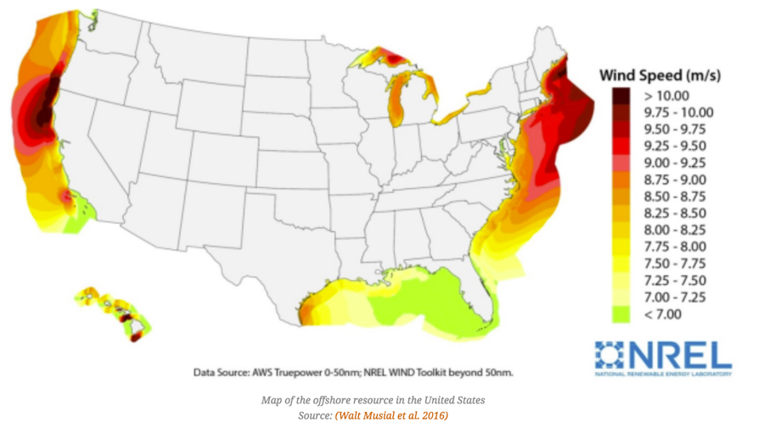

**Figure:** Offshore resource potential

Fifteen *techno-resource groups* (TRG) were developed to categorize the 7,000 sites depending on:

* Their substructure. There are four different substructures, two of which are fixed bottom while the other two are floating structures. The four substructures are *monopile* (fixed bottom), jacket (fixed bottom), semi-submersible (floating), and spar (floating).
* Capacity-weighted average CAPEX
* O&M
* Grid connection costs
* Capacity Factor

**Offshore wind:** CAPEX – historical and projected

* Water depth and distance to land

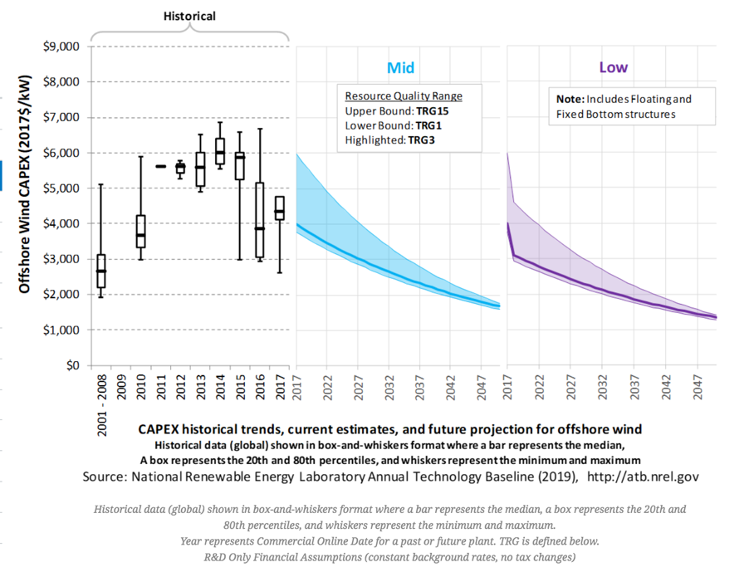TRG 1-5 are fixed bottom, and represent sites that are most likely to be developed in near-to-mid term. TRG 6-15, with the water depth and distance to land increasing from TRG 6 to TRG 15.

The historical and projected CAPEX is shown in chart to the right. The **Mid** and **Low** charts represent scenarios that are 50% and 10-30% likely to occur, respectively.

A similar visualization for historical and projected O&M costs are shown below.

**Offshore wind:** O&M historical and projected

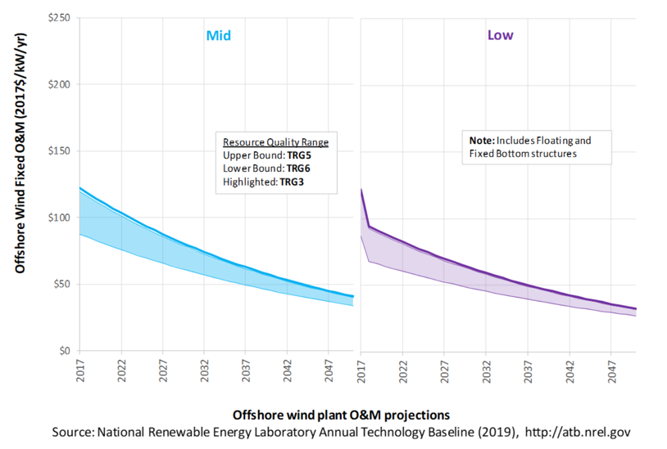

**Offshore wind:** Capacity factor historical and projected

* The upper bound is fixed bottom TRG 5, while the lower bound is floating TRG 6

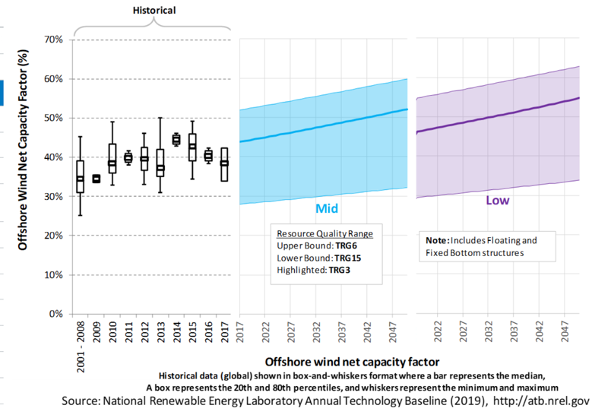

* The LCOE is less without tax credits and changing interest rates in the long term

**Offshore wind:** LCOE (incl. tax credits and changing interest rates)

**Offshore wind:** LCOE (excl. tax credits and changing interest rates)

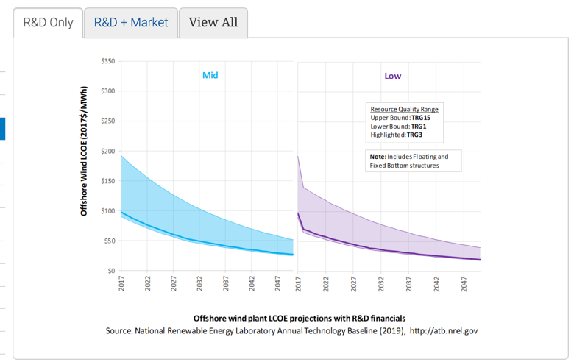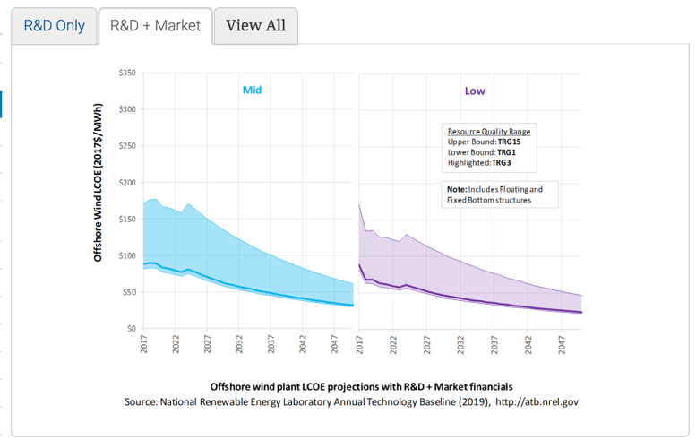

**Utility-Scale PV (**[https://atb.nrel.gov/electricity/2019/index.html?t=su**)**](https://atb.nrel.gov/electricity/2019/index.html?t=su))

The ATB for utility-scale PV is based on a one-axis tracking system with performance and pricing characteristics in line with a 1.3 DC-to-AC inverter loading rate (ILR).

**Intuitively, what is ILR?**

*Resource Potential*

In the United States, the resource potential is good to excellent, rated between per year. One estimate suggests that 0.6% of the country’s land area, or 22% of the urban area footprint dedicated to PV deployment will be sufficient for all end-use electricity needs.

**What is “urban area footprint”?**

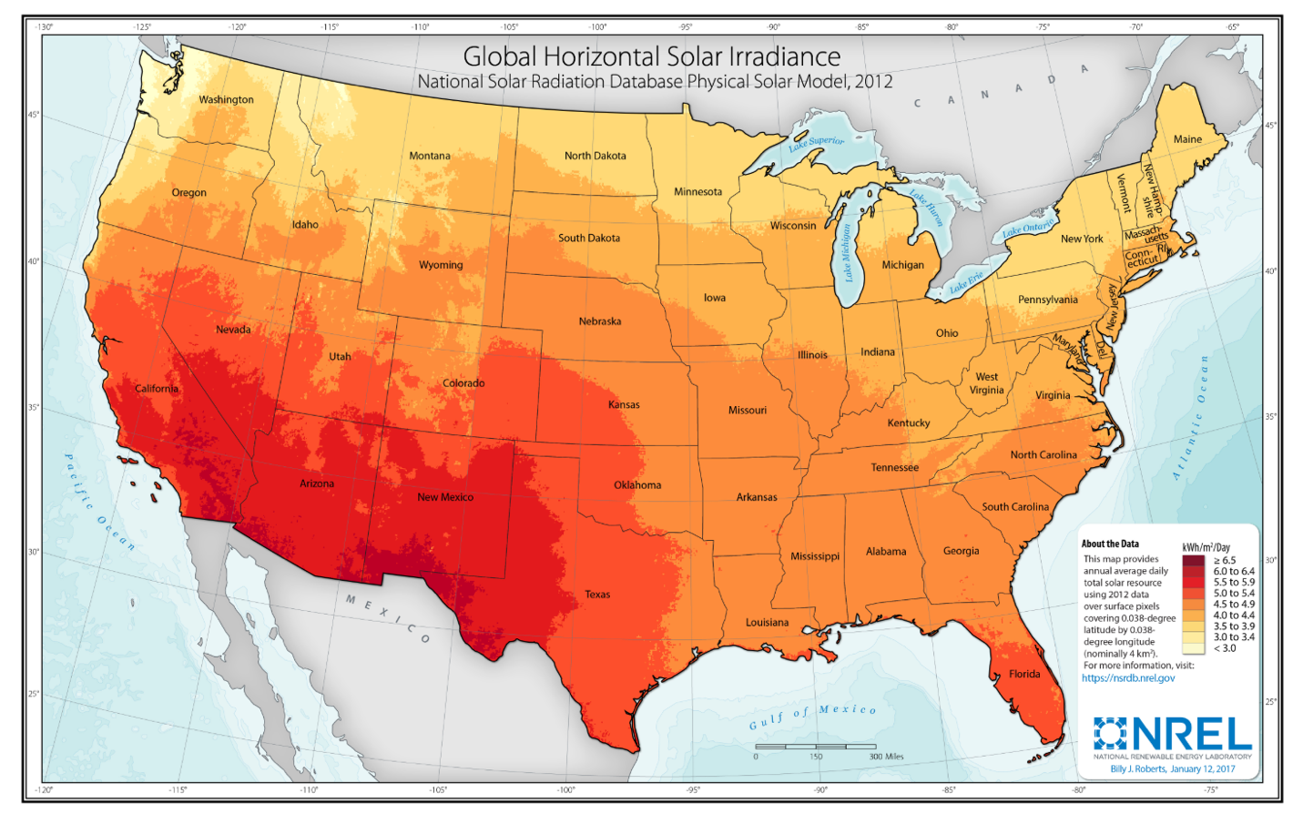

**Utility-scale PV:** Resource potential

*CAPEX*

In terms of utility-scale PV, CAPEX includes:

* Hardware
* Module supply
* Power electronics, including inverters
* Racking
* Foundation
* AC and DC wiring materials and installation
* Electrical infrastructure, such as transformers, switchgear, and electrical system connecting modules to each other and to the control center
* Balance of system (BOS)
* Land acquisition, site preparation, installation of underground utilities, access roads, fencing, and buildings for operations and maintenance
* Project indirect costs, including costs related to engineering, distributable labor and materials, construction management start up and commissioning, and contractor overhead costs, fees, and profit
* Financial Costs
* Owners' costs, such as development costs, preliminary feasibility and engineering studies, environmental studies and permitting, legal fees, insurance costs, and property taxes during construction
* Electrical interconnection, including onsite electrical equipment (e.g., switchyard), a nominal-distance spur line (< 1 mile), and necessary upgrades at a transmission substation; distance-based spur line cost (GCC) not included in the ATB
* Interest during construction estimated based on six-month duration accumulated 100% at half-year intervals and an 8% interest rate (ConFinFactor).

**Utility-scale PV:** CAPEX

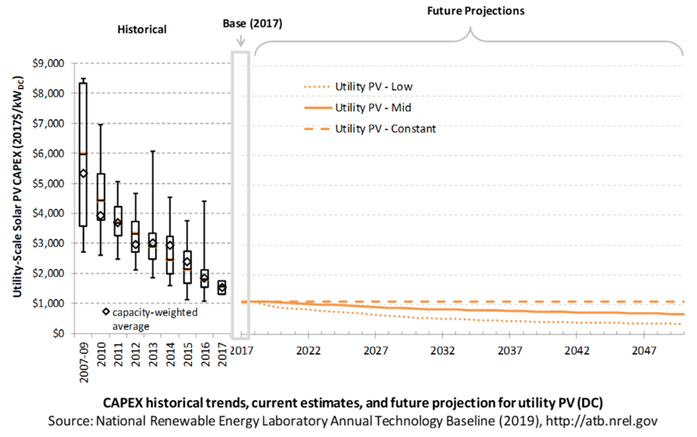

* This is reported in based on aggregated module capacity. The electric industry typically refers to CAPEX in based on aggregated inverter capacity
* The investment tax credit encourages costs to be counted as CAPEX instead of O&M, so it is possible CAPEX is inflated in comparison to O&M

*O&M*

For utility-scale PV, O&M costs include:

* Insurance, property taxes, site security, legal and administrative fees, and other fixed costs
* Present value and annualized large component replacement costs over technical life (e.g., inverters at 15 years)
* Scheduled and unscheduled maintenance of solar PV plants, transformers, etc. over the technical lifetime of the plant (e.g., general maintenance, including cleaning and vegetation removal).

**Utility-scale PV:** O&M

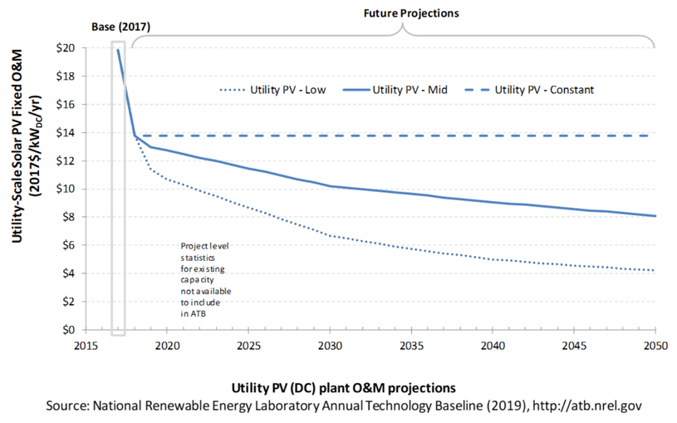

*Capacity Factor*

The capacity factor is influenced by the hourly solar profile, technology (e.g., thin-film/crystalline silicon), axis type (none, one, or two), expected downtime, and inverter losses to transform DC >> AC power.

**Utility-scale PV:** Capacity Factor

* 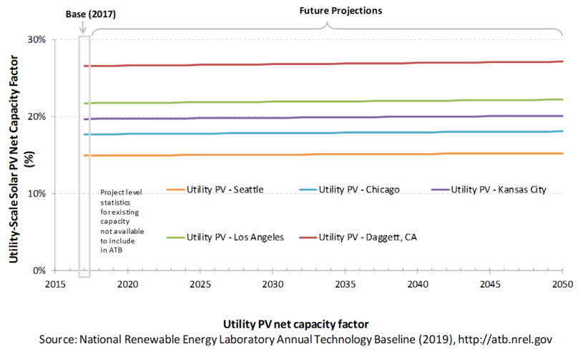Capacity factor is based on degradation rate of .75% per year over the lifetime of the plant
* This chart uses specific locations representative of high, high-mid, mid, mid-low, and low resource areas in the conUS.

**­­***Project cost*

Currently, CAPEX is the most commonly used metric to estimate project cost, as opposed to LCOE. LCOE can be confusing because of varying assumptions regarding long-term incentives, system location and production characteristics, and cost of capital.

With this in mind, projections of future utility-scale PV plant CAPEX are based on 11 system price projections from 9 separate institutions.

**Utility-scale PV:** Project cost

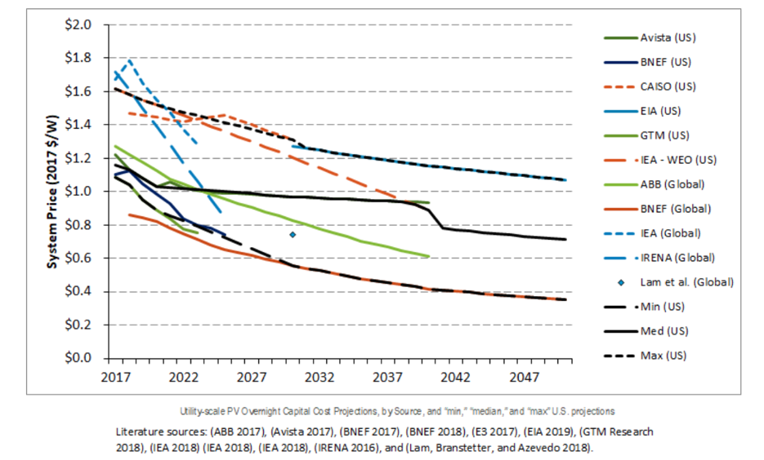

* Some institutions are focused on short-term projections, others on a longer time horizon

*LCOE*

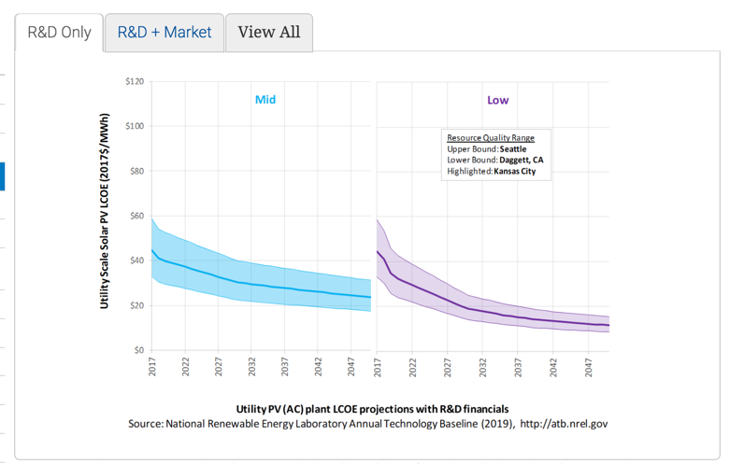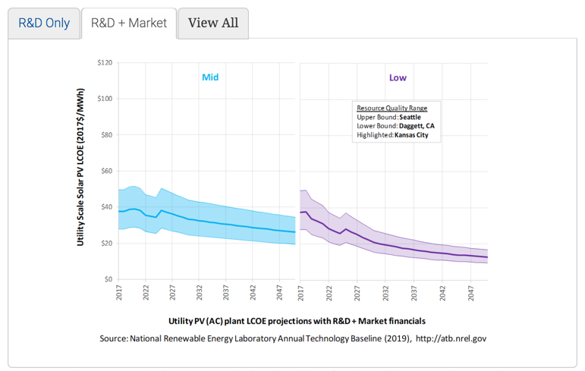

**Utility-scale PV:** LCOE (incl. tax credits and changing interest rates)

**Utility-scale PV:** LCOE (excl. tax credits and changing interest rates)

**Assumptions**

Photosynthesis converts solar energy into chemical energy that is stored in and used by biological systems. This is the principal mechanism that has powered life on Earth for billions of years, and remains the source of almost all energy used by humanity.